Thinking and Learning
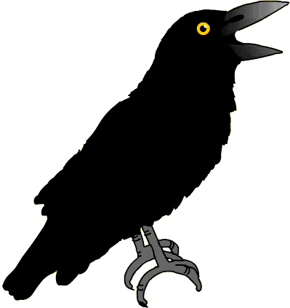
Through

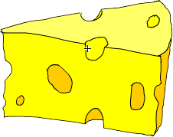
Fables

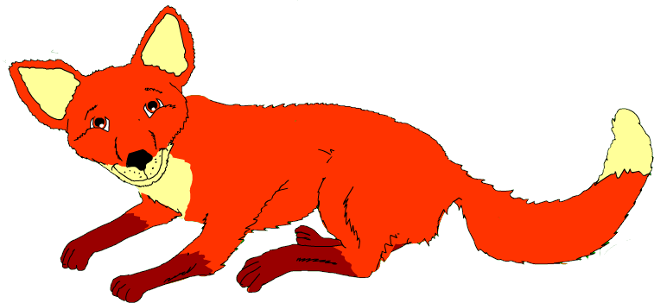
In

Modern Foreign Languages

Card Sorting - Phonics

Purpose | - to sort, classify and group words  - to make connections  - to develop listening skills
Links to KS2 framework | - KAL Recognise patterns  - KAL Develop accuracy in pronunciation
Preparation | Pupils work in groups of 2 or 3. Each group will need:  - 1 phonic grid  - 1 set of phonic cards  It is advisable to use no more than 10 phonic words in any one session and to concentrate on just a few sounds at a time.
Activity | - Display phonic grid on power point or Smart board and practise sounds. It is a good idea to introduce a beat or rhythm to assist recall. “We will rock you” by Queen is a good one.  - Give out set of 10 words. Say each word and ask groups to place in order in which you say them.  - Give out phonic grids.  - Now ask groups to sort the words by sound endings placing each word in correct column of the grid.  - Invite groups to feed back to whole class by listing words in one of the columns.  - Invite comment from other groups. Any uncertainties should be verified by listening to the animated version of the story.
Debrief | Ask pupils what they learned and found surprising about the language through the process. What skills did they use? I.e. listening, discussing, reasoning, etc.

è | é | ô | u | an | on

è | é | ô | u | an | on
près | décidé | corbeau | vu | dans | bon
très | chercher | eau | descendu | temps | son
avait | manger | morceau | plus | vraiment | chanson
est | côté | mots |  | maintenant | leçon
tenait | Et/ces | beau |  | décidément | raison
j’ai | retourné | vaut |  | en
n’ai | semblez |  |  | content
 | dîner
Story Boarding

Purpose | - to develop sequencing skills  - to make deductions  - to make judgements informed by reasons and evidence  - to develop language learning strategies and knowledge about language
Links to KS2 framework | - KAL Use knowledge of words, texts and structure to make meaning  - 06.1 Understand the main points in a story  - L6.1 Read and understand the main points and some detail from a short written passage
Preparation | Pupils work in groups of 3 or 4. Each group will need:  - 1 set of picture cards
Activity | - Ask pupils to sequence the cards in the order in which they appear in the story.  - Using the animated on screen version ask class to find the French words for the pictures that appear on the first page. Ask them to explain their choice. Right or wrong, the reasons they give are very important as they are articulating language learning strategies. If word selected is incorrect ask class if there could be another word for the picture. Ask for reasons. Continue until correct word is identified.  - Once they have identified the words for the pictures that appear on the first page of the story, ask them to repeat the words after you. Ask them to comment on the sound and the spelling of the words – make links to phonic grid.  - Now ask them to listen to that page being read and to point to the pictures when they hear the words.  - Now remove the text and ask them to listen again to see if they can identify the words.  - Replay the first page with the text and ask them to try and join in when the word is said. Tell them that you intend to remove the text and would like them to still join in. Ask what they need to focus on to be able to do this.  Repeat for next few pages.
Debrief | Ask pupils what they discovered about language through the process and how they discovered it. What skills did they use? I.e. discussing, explaining, reasoning, justifying, making judgements etc.

 | 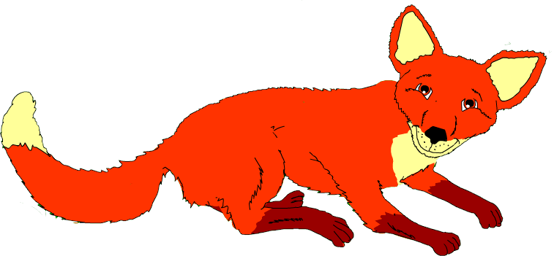 |  | 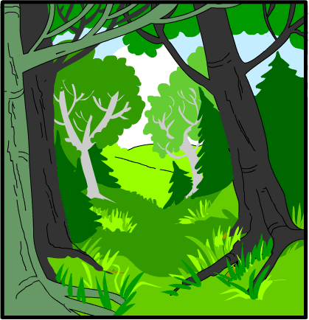
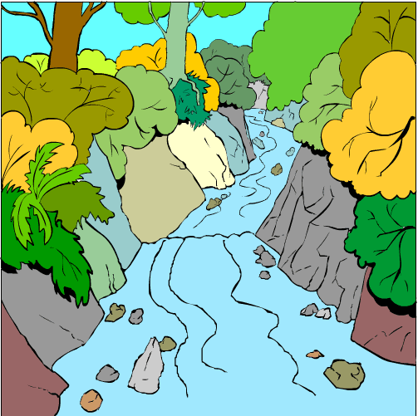 |  | 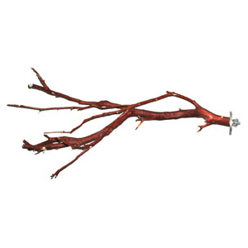 | 

Card Sorting – Nouns 1

Purpose | - to sort, classify and group words  - to articulate precisely reasoning process  - to develop language learning strategies and knowledge about language
Links to KS2 framework | - KAL Recognise patterns in the foreign language  - KAL Appreciate that different languages use different writing conventions
Preparation | Pupils work in groups of 3 or 4. Each group will need:  - 1 set of noun cards
Activity | - Give out the cards to each group. Say the words on each card and ask pupils to put them into the sequence as you say them. Discuss any that were difficult to identify.  - Ask pupils to sort the cards into groups.  - After 5 minutes ask each group how they chose to sort.  - Whatever way groups have sorted the words go in that direction. For example if a group has sorted into words they know and don’t know; check the meaning of the words that they think they know in the story. Listen to the pronunciation of the words and practice repeating them.  - Now look in the story to work out the meaning of the group of words they didn’t know. Listen to the sounds of the new words and practice the pronunciation. Relate to phonic grid.  - If they still can’t work out the meaning what other strategies do they think they could they employ?  - Ask them to choose a favourite word and to draw it in the air on the back of their partner. In pairs or groups try and guess each other’s favourite word.
Debrief | Ask pupils what they discovered about language through the process and how they discovered it. What skills did they use? I.e. discussing, explaining, reasoning, deducing, justifying etc.

un corbeau | un corbeau | un corbeau | un corbeau
un bois | un bois | un bois | un bois
une rivière | une rivière | une rivière | une rivière
un renard | un renard | un renard | un renard
le fromage | le fromage | le fromage | le fromage
le bec | le bec | le bec | le bec
la branche | la branche | la branche | la branche
l’arbre | l’arbre | l’arbre | l’arbre
une voix | une voix | une voix | une voix
le phénix | le phénix | le phénix | le phénix
une chanson | une chanson | une chanson | une chanson
une leçon | une leçon | une leçon | une leçon

Card Sorting – Nouns 2

Purpose | - to sort, classify and group words  - to articulate precisely reasoning process  - to make links between words  - to develop language learning strategies and knowledge about language
Links to KS2 framework | - KAL Recognise patterns in the foreign language  - KAL Appreciate that different languages use different writing conventions  - KAL Notice and match agreements
Preparation | Pupils work in groups of 3 or 4. Each group will need:  - 1 set of noun cards
Activity | - Give out the cards to each group. Say the words on each card and ask them to put them into the sequence as you say them. Discuss any that were difficult to identify.  - Ask pupils to sort the cards into groups.  - After 5 minutes ask each group how they chose to sort.  - Whatever way groups have sorted the words go in that direction.  - Some groups will probably sort gender. Ask pupils to explain what the “le” and “la” “un” and “une” could mean and consequently to articulate precisely how they have sorted – i.e. by gender.  - Confirm their understanding by checking in the story. Gender is a difficult concept for English speakers, give pupils time to reflect on the concept.  - If they show interest in the gender issue, use pages 2 and 3 of the word cards, which allow them to explore the issues of gender and plurality.  - Give each group a selection of the words on pages 2 and 3. Ask pupils to make short phrases out of their words by thinking carefully about the gender. Ask them to check that each word in a phrase matches in terms of gender, singular or plural.  - Ask each group to feed back a selection of their phrases. Ask other groups to comment.
Debrief | Ask pupils what they discovered about language through the process and how they discovered it. What skills did they use? I.e. discussing, explaining, reasoning, deducing, justifying etc.

corbeau | corbeau | corbeau | corbeau
bois | bois | bois | bois
rivière | rivière | rivière | rivière
renard | renard | renard | renard
fromage | fromage | fromage | fromage
bec | bec | bec | bec
branche | branche | branche | branche
arbre | arbre | arbre | arbre
voix | voix | voix | voix
phénix | phénix | phénix | phénix
chanson | chanson | chanson | chanson
leçon | leçon | leçon | leçon

le | le | le | le
la | la | la | la
l’ | l’ | l’ | l’
un | un | un | un
une | une | une | une
petit | petit | petit | petit
petite | petite | petite | petite
grand | grand | grand | grand
grande | grande | grande | grande

Venn Diagram

Purpose | - to classify information  - to see similarities, differences and relationships  - to develop understanding of adjectival agreements
Links to framework | - KAL Recognise patterns in the foreign language  - KAL Notice and match agreements
Preparation | Pupils work in groups of 3 or 4. Each group will need:  - 1 venn diagram  - 1 word sheet  - 1 copy of fable  - 1 non permanent marker
Activity | - Place Venn diagram and word sheet on tables – one per group.  - Give pupils 2 minutes to notice 3 things about the words on the sheet. Ask for feedback.  - Give pupils 2 minutes to work out what to do with the words and the Venn diagram. Ask for feedback. It is more challenging and engaging for pupils to work out what they have to do than to be told.  - Ask pupils to write the words onto the diagram, using the fable for reference when necessary.  - Ask each group to feed back and to justify the decisions they have made.  - Ask other groups for comments.
Debrief | Ask pupils what they discovered about language through the process and how they discovered it. What skills did they use? I.e. discussing, explaining, reasoning, justifying, enquirying etc.

belle | petite | jolie | contente
malin | sage | bon | gentille
honteuse | beau | triste | gênée
heureux | content | maligne | grand
fière | délicieuse | noir | sûre
Noire | gêné | honteux | délicieux
gentil | grande | bête | petit
joli | sûr | heureuse | fier
bonne | super | cool | fantastique

Map from Memory – Visual

Purpose | - to interpret and organise information  - to make links between words  - to look for patterns  - to develop memory strategies
Links to KS2 framework | - O5.4 Develop and consolidate memorisation skills  - O5.4 Remember, retain and recall words
Preparation | Pupils work in groups of 3 or 4. Each group will need:  - A blank map  - One set of visuals and words
Activity | - Tell pupils that there is one copy of the “map” and that they have to reproduce it, as a group, as accurately as possible.  - Ask groups to give a number 1,2,3 or 4 to each team member.  - Team members Number 1 come to look at the map for 10 seconds.  - They then go back to their groups and tell other members what they can recall. They are not allowed to touch the visuals or phrase cards.  - Other group members try to construct the map.  - Repeat above two stages for each member of the group and for as many times as you deem necessary.  - When the time is up ask groups to wander around and look at the maps produced by other groups.  - Reveal original map on power point. Ask for feedback on the activity.
Debrief | Ask pupils what strategies they employed to carry out the task. Ask them  - what they did well  - what they could do better  - what they would do differently if they were to do the activity again  What skills did they use? I.e. discussing, collaboration, listening, planning, explaining, reasoning, justifying etc.

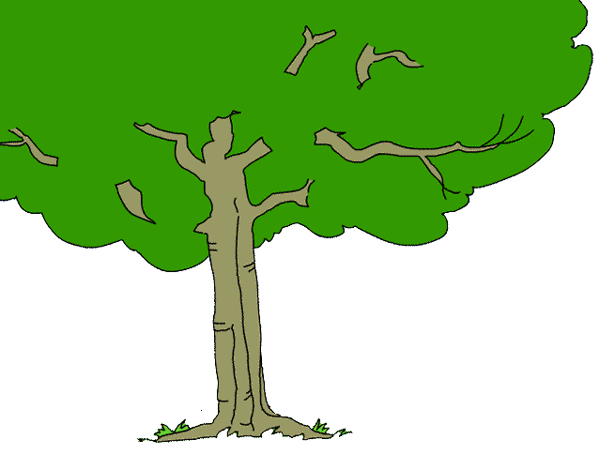

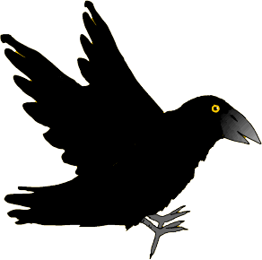

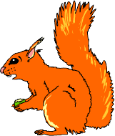
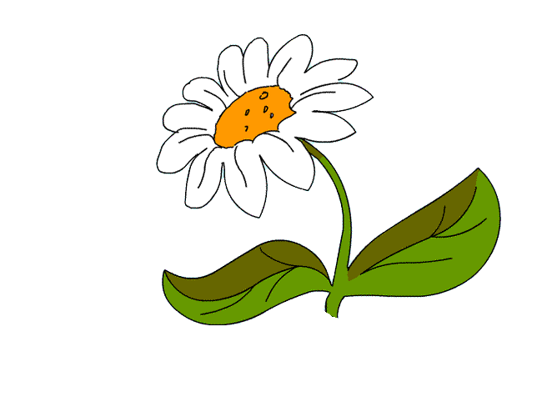
un grand corbeau noir
un petit renard
des arbres
une petite souris
une petite rivière
un écureuil
des fleurs
Un Joli Bois
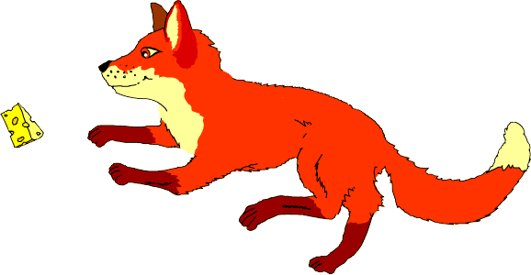
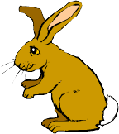
du fromage
deux petits lapins

une petite rivière | une petite rivière | une petite rivière | une petite rivière
un petit renard | un petit renard | un petit renard | un petit renard
un grand corbeau noir | un grand corbeau noir | un grand corbeau noir | un grand corbeau noir
des arbres | des arbres | des arbres | des arbres
deux petits lapins | deux petits lapins | deux petits lapins | deux petits lapins
un écureuil | un écureuil | un écureuil | un écureuil
une petite souris | une petite souris | une petite souris | une petite souris
du fromage | du fromage | du fromage | du fromage
des fleurs | des fleurs | des fleurs | des fleurs
Un Joli Bois | Un Joli Bois | Un Joli Bois | Un Joli Bois

Map from Memory – Auditory

Purpose | - to interpret and organise information  - to develop memory strategies  - to develop listening skills
Links to KS2 framework | - O5.1 Focus on correct pronunciation and intonation  - O5.2 Make short texts using word and phrase cards  - L6.3 Match sound to sentences and paragraphs
Preparation | Pupils work in groups of 3 or 4. Each group will need:  - 1 set of phrase cards
Activity | - Give one set of cards to each group of pupils. Read the phrases aloud and ask pupils to sequence in the order in which they hear them.  - Now ask pupils to set cards upside down on the table.  - Each pupil takes it in turns to turn up a card and to read it aloud in French.  - Ask the groups to look at the phonics in the words on the cards.  - Ask groups to give a number 1,2,3 or 4 to each team member.  - Team members Number 1 come to hear the text.  - They then go back to their groups and tell other members what they can recall. They are not allowed to touch the phrase cards.  - Other group members try to construct the text in the correct order.  - Repeat above stages for each member of the group and for as many times as you deem necessary.  ( Any page from the story can be used for this activity)
Debrief | Ask pupils what strategies they employed to carry out the task. Ask them  - what they did well  - what they could do better  - what they would do differently if they were to do the activity again  What skills did they use? I.e. discussing, collaboration, listening, planning, explaining, reasoning, justifying etc.

Il était une fois | un grand |  | Il était une fois | un grand
corbeau noir. | Il habitait |  | corbeau noir. | Il habitait
un joli bois | près d’une |  | un joli bois | près d’une
petite rivière. | Dans |  | petite rivière. | Dans
ce joli bois | habitait |  | ce joli bois | habitait
aussi | un petit renard |  | aussi | un petit renard
qui était | très malin. |  | qui était | très malin.
Il était une fois | un grand |  | Il était une fois | un grand
corbeau noir. | Il habitait |  | corbeau noir. | Il habitait
un joli bois | près d’une |  | un joli bois | près d’une
petite rivière. | Dans |  | petite rivière. | Dans
ce joli bois | habitait |  | ce joli bois | habitait
aussi | un petit renard |  | aussi | un petit renard
qui était | très malin. |  | qui était | très malin.

8 Questions

Purpose | - to formulate questions  - to develop questioning techniques  - to generate ideas  This strategy should be ongoing for the duration of the fable so that the pupils develop a bank of questions relating to the fable. It is not necessary to find answers to the questions. It is appropriate to explore certain questions after certain activities, e.g.  Où after card sorting of nouns – où est le corbeau? etc  Combien de after card sorting of nouns – combien de corbeaux dans le bois? etc  Qui after work on adjectives – qui est malin? etc.  Also after work on verbs – qui a vu le fromage ?  Pourquoi after work on verbs – pourquoi le corbeau a chanté ? etc  Qu’est-ce que after work on verbs – qu’est-ce que le renard a mangé ?  Quand after work on verbs – quand est-ce que le corbeau a chanté ? etc
Links to KS2 framework | - 05.2 Ask and answer questions  - L5.2 Understand that the order of words in a sentence influences the meaning  - O6.4 Use spoken language confidently to initiate and sustain conversations
Preparation | Pupils work in groups of 3 or 4. Each group will need:  - One 8 questions diagram  - 1 language grid  - One copy of the fable
Activity | - Write one question in the language grid e.g. “Où est le corbeau? »  - Give groups 30 seconds to work out what kind of statement it is and why; which is the most important word in the statement and why.  - Ask them if they could create a new question by changing any of the words. They need to have an awareness of gender in order to do this correctly.  - Write “Il est où le corbeau?” on the grid and ask class what it means, and what has changed from the first question. This is a very French way of asking questions. Ask what would change if it was “rivière” instead of “corbeau”.  - Ask pupils to make up as many “où” questions as they can relating to the story using both question formats.  - Pupils can wander round and look at the questions of other groups.  - Groups can feedback interesting questions to whole class.  - Now ask groups to make up “où” questions relating to the classroom / school / town / etc
Debrief | Ask pupils what skills they used to create their own questions? I.e. imagining, discussing, explaining, reasoning, justifying etc.

Où |  | est |  | le | grand | corbeau | noir?
 | Il | est | où | le | grand | corbeau | noir?
Qui…?
Où…?
Pourquoi…?
Comment…?
Quel / Quelle…?
Combien de…?
Quand…?
Qu’est-ce que…?
Huit
questions

Fortune Line

Purpose | - to interpret information and organise it  - to make links between pieces of information  - to formulate, explain and justify opinions  - to empathise with characters in the story
Links to KS2 framework | - O5.2 Understand and express simple opinions  - O6.3 Understand longer and more complex sentences  - O6.4 Use spoken language confidently to initiate and sustain  conversations  - L6.1 Read and understand the main points and some detail from a short written passage
Preparation | Pupils work in groups of 3 or 4. Each group will need:  - 1 fortune line graph  - 1 set of phrases  - 1 non permanent marker
Activity | - Give out the phrase cards.  - Ask pupils to sequence phrases in the order in which you say them, repeating them after you.  - Now ask them to re-order them in the order of the original story. Give pupils a blank copy of the graph.  - Ask pupils to place each slip in order along the bottom of the graph, matching the text to the number, reading the phrase aloud as they do so.  - Ask pupils to decide how le corbeau feels at each stage and to mark a point on the graph to represent its feelings.  - Ask pupils to wander around and look at the other graphs.  - Ask each group to feed back by describing its line in French and explaining its decisions.  - Pupils could plot another line to represent how le renard felt at each stage.
Debrief | Ask pupils how they came to an agreement on where to plot their lines. What skills did they use? I.e. listening, discussing, explaining, reasoning, justifying etc.

☺  très content  assez content  mécontent  très fier  😐  heureux  ☹  malheureux  ☹  idiot  ☹  furieux | Le corbeau est…
 | 1 | 2 | 3 | 4 | 5 | 6 | 7 | 8 | 9 | 10
Ici
Là

A | Il a ouvert son bec. | A | Il a ouvert son bec.
B | Le renard l’a tout mangé. | B | Le renard l’a tout mangé.
C | Il est parti rechercher son dîner. | C | Il est parti rechercher son dîner.
D | Le corbeau avait faim. | D | Le corbeau avait faim.
E | Le fromage est tombé par terre. | E | Le fromage est tombé par terre.
F | Il a vu le fromage par terre. | F | Il a vu le fromage par terre.
G | Il a écouté la leçon du renard. | G | Il a écouté la leçon du renard.
H | Il a pris le fromage dans son bec noir. | H | Il a pris le fromage dans son bec noir.
I | Le renard a saisi le fromage. | I | Le renard a saisi le fromage.
J | Le corbeau a chanté une chanson. | J | Le corbeau a chanté une chanson.

Kim’s Game

Purpose | - to identify strategies for memorising
Links to KS2 framework | - O5.4 Develop and consolidate memorisation skills  - O5.4 Remember, retain and recall words and phrases
Preparation | A basket containing about 10 items relating to the fable. These could be:  A pretty flower A song  A small bird A stone  A piece of cheese A fish  A green leaf A branch  A crafty fox A ball
Activity | - Tell pupils that you are going to place some items on the table and then cover them up.  - Tell class that you would like them to try and remember the objects.  - Take out the objects one at a time. It can be useful to say the name of the object, and add an appropriate action before placing it on the table. This often becomes part of the memorisation process for different types of learners.  - Give about 30 seconds for looking at all the objects together on the table, then cover up or put away.  - Give pupils about a minute to recall as many objects as possible. Note: do not tell them how this should be done. They often assume that it must be done alone – if they choose to work with someone else do not stop them.
Debrief | Ask pupils what strategies they used to remember the objects. Write the various strategies on the board. Discuss the nature of the different strategies and what it would be like to adopt a different one.

Odd One Out

Purpose | - to identify similarities and differences  - to promote understanding of properties and attributes of words  - to develop reasoning skills and knowledge about language
Links to KS2 framework | - KAL Recognise patterns  - KAL Notice and match agreements
Preparation | Pupils work in groups of 2 or 3. Each group will need:  - 1 odd one out grid
Activity | - Read out the words in each column for number 1. Ask pupils to repeat.  - Ask groups to choose an odd one out and to explain their choice (say why…). Emphasise that there are no right or wrong answer, but that all answers must be explained.  - Ask them to write down their explanation in English.  - Repeat for each numbered line.  - Ask one group to read out words in one of the lines from the power point. Ask them to feed back on their choice of Odd One Out.  - Ask other groups for comments.  - Repeat the process for the other lines.  - When all the lines are completed ask groups to make up their own odd one outs using words or phrases from the story.
Debrief | Ask pupils what knowledge about language they discovered during the activity. Ask them how they discovered it. What skills did they use? I.e. discussing, explaining, reasoning, justifying etc.

Cherchez l’intrus.

Choisis l’intrus sur chaque ligne et explique ton choix.

 | A | B | C | D |  | POURQUOI?
1 | Petite | Joli | Malin | Bon

2 | Le corbeau | Le fromage | Le renard | Joli

3 | La rivière | Le plumage | La voix | La branche

4 | La leçon | Malin | Bon | Honteux

5 | La voix | Le fromage | Noir | Le bois

6 | Grand | Sage | Heureux | Jolie

7 | Dans | À côté de | Sur | C’était

8 | Il est retourné | Il a regardé | Il est parti | Il est descendu

À toi!

 | A | B | C | D |  | POURQUOI?
1

2

3

4

5

Fact or Opinion

Purpose | - to distinguish fact from opinion  - to develop reasoning skills
Links to KS2 framework | - O5.2 Understand and express opinions  - O6.1 Understand simple opinions in a story
Preparation | Pupils work in groups of 2 or 3. Each group will need:  - 1 sheet of phrases per group
Activity | - Give sheet of phrases to each group of pupils.  - Ask group members to take turns in reading each statement aloud.  - Ask groups to decide if each phrase is a fact or opinion and to write an F or an O in the box accordingly.  - Ask groups to feedback using “A notre avis…” for the opinions and “il est certain que…” for the facts.
Debrief | Ask pupils what skills they employed to reach a decision for each statement. Whose view points did they have to consider?  Ask pupils if they found the activity easy. If not, why not? What skills did they need to use? I.e. discussing, justifying explaining, reasoning, deducing bias and reliability, etc.

Fait ou Opinion?

Le bois est près de la rivière. |  | Le bois est joli.
Le corbeau est grand. |  | Le renard mange le fromage.
Il y avait du fromage par terre. |  | Le corbeau chante mal.
Le renard est roux. |  | Le corbeau est sur une branche d’un arbre.
Le corbeau a faim. |  | Le fromage est délicieux.
Le fromage tombe par terre. |  | Le renard est intelligent.
Le fromage sent bon. |  | Le corbeau a un bec noir.
Il y a des arbres dans le bois. |  | Les flatteurs sont malhonnêtes.

Card Sorting – Verbs 1

Purpose | - to sort, classify and group words  - to identify relationships  - to make connections  - to develop understanding of the nature of verbs
Links to KS2 framework | - KAL Recognise patterns in the foreign language  - KAL Recognise the typical conventions of word order in the foreign language  - KAL Understand that words will not always have a direct equivalent in the foreign language
Preparation | Pupils work in groups of 3 or 4. Each group will need:  - 1 set of infinitive cards in French  - 1 copy of fable
Activity | - Give out set of French infinitive cards and ask groups to sort into groups – do not specify criteria.  - Ask groups to feedback on their choice of groupings and to explain the reasons for their choice. Compare feedback from different groups.  - Now write “to imagine” on the board. Ask groups to find the French word that means “to imagine”. Now ask them what “decider” means. Get them to talk about the fact that there are 2 words in English for the 1 French word.  - Ask groups to re-sort their cards according to meaning – ones they think they know and ones that they have no idea. They can refer to the fable to help them.  - Ask groups to compare their results with another group.  - Some groups will start to puzzle over the “se” words. Let them offer suggestions. If necessary ask the type of questions that could lead them to the idea of self. If they get the idea write “s’appeler” on the board and ask what it means, then “je m’appelle”.  - It would be a good idea to play blockbusters and snakes and ladders in subsequent lessons before moving onto the next verb sorting activity. This will build up confidence with the verbs in the story and will encourage the use of “to…” in English when referring to an infinitive.
Debrief | Ask pupils what they discovered about language through the process and how they discovered it. What skills did they use? I.e. discussing, reasoning, deducing, hypothesising etc.

habiter | chanter | écouter | voir | descendre
décider | montrer | s’approcher | avoir | prendre
chercher | sembler | se jurer | valoir | vivre
imaginer | manger | partir | savoir | être
retourner | aller | saisir | sentir | dire
tomber | regarder | tenir | ouvrir | se sentir

Card Sorting – Verbs 2

Purpose | - to sort, classify and group words  - to identify relationships  - to make connections  - to develop understanding of the nature of verbs
Links to KS2 framework | - KAL Recognise patterns in the foreign language  - KAL Recognise the typical conventions of word order in the foreign language  - KAL Understand that words will not always have a direct equivalent in the foreign language
Preparation | Pupils work in groups of 3 or 4. Each group will need:  - 1 set French verb cards – past tense only  - 1 set of infinitive cards in French  - 1 copy of fable
Activity | - Give out the French infinitives cards and a set of cut up past tense verbs cards.  - Ask groups to match the words to the infinitives.  - Ask for feedback – were any difficult? Any observations?  - Ask what “habiter” means. Now look for “habitait” on page 1 of the story and ask what it could mean. Repeat for a couple more of the verbs. Ask them to articulate the differences between the infinitive and the conjugated verb.  - Now take away the infinitive cards and ask groups to sort into groups.  - Ask for feedback.  - Ask groups to choose one verb from each of their groups and to decide if it is in the past, present or future tense by looking in the story.  - Ask for feedback. Once the class has established that they are all in the past tense, give out the 2 oval shapes. Now ask the groups to look in the story and to decide if the verbs indicate an action or a description and to group them accordingly.  - Ask for feedback. What patterns do they notice?  - The objective of this activity is for pupils to start seeing patterns and to become aware of the steps involved in conjugating verbs. They do not need to learn the patterns.
Debrief | Ask pupils what they discovered about language through the process and how they discovered it. What skills did they use? I.e. discussing, reasoning, deducing, hypothesising etc.

Description
Action
était | a regardé | est descendu | êtes
habitait | a décidé | est retourné | est
avait | a vu | est tombé | ai
tenait | a pris | est parti | a
sentait | a dit | s’est juré | savez
s’approchait | a ouvert | vaut | semblez
se sentait | a saisi | vivent | chantez
vais | a mangé | écoutent | imagine

Card Sorting – Verbs 3

Purpose | - to sort, classify and group words  - to identify relationships  - to make connections  - to develop understanding of the nature of verbs
Links to KS2 framework | - KAL Recognise patterns in the foreign language  - KAL Recognise the typical conventions of word order in the foreign language  - KAL Understand that words will not always have a direct equivalent in the foreign language
Preparation | Pupils work in groups of 3 or 4. Each group will need:  - 1 set French verb cards – present tense only  - 1 set of infinitive cards in French  - 1 copy of fable
Activity | - Give out the French infinitives cards and a set of cut up present tense verbs cards.  - Ask groups to match the words to the infinitives.  - Ask for feedback – were any difficult? Any observations?  - Now take away the infinitive cards and ask groups to sort into groups.  - Ask for feedback.  - Ask groups to choose one verb from each of their groups and to decide if it is in the past, present or future tense by looking in the story.  - Ask for feedback.  - Now ask groups to choose 4 of their verb cards and to try and find out from the story who is doing the listening or the singing etc, i.e. who is the subject of the verb.  - Ask for feedback.  - On the smart board write  - Je / j’  - Tu  - Il / Elle  - Nous  - Vous  - Ils / Elles  - Ask groups if any of their verbs could go with “vous”. What could vous mean? Repeat with “je”. Ask what pronoun would work for the other verbs. Why? .  - Ask for feedback. What patterns do they notice?  - The objective of this activity is for pupils to start seeing patterns and to become aware of the steps involved in conjugating verbs. They do not need to learn the patterns.
Debrief | Ask pupils what they discovered about language through the process and how they discovered it. What skills did they use? I.e. discussing, reasoning, deducing, hypothesising etc.

Dominoes

Purpose | - to sort words  - to make connections  - to develop memory skills
Links to KS2 framework | - O5.4 Remember, retain and recall words  - KAL use knowledge of words to make meaning
Preparation | Pupils work in groups of 3. Each group will need:  - 1 set of dominoes
Activity | - ask the class to distribute the dominoes equally among group members  - pupil with * * * places his card on the table saying the French word aloud  - continue as a game of dominoes ensuring that the French words are said aloud.  - Continue until final * * * card is laid
Debrief | Ask pupils what skills they employed during the game. i.e. listening, memorising, reasoning. Ask if they learned any new words. How did they learn them?

* *  Le corbeau  et  le renard | a crow |  | un corbeau | delicious
délicieux | a river | une rivière |  | pretty
joli | nasty | méchant |  | proud
fier | a beak | un bec |  | happy

content | a tree | un arbre | wise
sage | a song | une chanson | good
bon | a flatterer | un flatteur | cunning
malin | a supper | un dîner | beautiful

beau | a branch | une branche | creamy
crémeux | a wood | un bois | once  upon a time
il était  une fois | some cheese | du fromage | black
noir | nice | gentil | small

petit | a voice | une voix | tall
grand | a word | un mot | as well
aussi | a fox | un renard | one fine day
un beau jour | hungry | faim | * * *  C’est fini!

Snakes and Ladders

Purpose | - to make connections  - to take turns  - to make decisions
Links to KS2 framework | - O5.4 Develop and consolidate memorisation skills  - O5.4 Remember, retain and recall words
Preparation | - Children sit in groups of 3. Each group has  - One snakes and ladders board  - One set of counters and dice  - One verb sheet – numbered randomly from 1 to 30 in boxes
Activity | Pupils take it in turns to throw dice.  If pupils land on a red square, they climb up the ladder, if they land on a blue square, they slide down the snake.  Each time pupils throw the dice, they move that number of places.  They must find the English equivalent of the verb that corresponds to the number they land on.  If they can’t find the equivalent or forget to say “to…” they miss their next go.  The game can be used with other year groups in a more challenging way to practice conjugating verbs.  If they land on a number with “je” they have to say that form of the verb in a specified tense. Can be played with one or more tenses, i.e. odd numbers – perfect; even – imperfect; red and blue numbers – present.
Debrief | Ask pupils what skills and dispositions they used during the activity. i.e. taking turns, being fair, reasoning

25je | 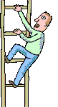  26tu | 27elle | 28nous | 29vous | 30ils
24je | 23tu | 22il | 21nous | 20vous | 19elles
13je | 14tu | 15on | 16nous | 17vous | 18ils
12je | 11tu | 10elle | 9nous | 8vous | 7elles
1je | 2tu | 3il | 4nous | 5vous | 6ils

 | habiter |  | savoir |  | aller
 | retourner |  | sentir |  | être
 | tomber |  | décider |  | partir
 | descendre |  | sembler |  | se sentir
 | saisir |  | écouter |  | imaginer
 | tenir |  | vivre |  | montrer
 | s’approcher |  | s’appeler |  | manger
 | se jurer |  | dire |  | voir
 | regarder |  | chercher |  | avoir
 | prendre |  | chanter |  | ouvrir

Blockbusters

Purpose | - to make connections  - to solve problems
Links to KS2 framework | - O5.4 Develop and consolidate memorisation skills  - O5.4 Remember, retain and recall words
Preparation | Pupils play in groups of 4 – 2 to a team. Each group will need:  - 1 blockbusters board  - 1 set of questions  - 1 water soluble marker pen  Pupils must try to get from the left to the right side of the game board.
Activity | - First team chooses a hexagon on the board and answers corresponding question.  - If they answer correctly they mark an X on the hexagon  - Second team follows same procedure but uses a different symbol to track progress  - After the first go, teams can only choose hexagons that touch an answered shape.  - If the question is incorrectly answered the shape is left blank.  - The questions are designed to practise the infinitives found in the story.  - The level of challenge can be increased with the aid of a dice.  - When pupils select their hexagon they throw the dice and conjugate the verb accordingly, selecting their preferred tense.  1- je; 2 – tu; 3 – il; 4 – nous; 5 – vous; 6 – ils
Debrief | Ask pupils what they learned and how they learned it. What skills did they use? I.e. listening, reasoning, etc. What dispositions did they need? i.e. turn taking.

I
M
D
A
O
P
T
M
C
S
S
T
D
V
J
S
R
S
E
V
D
R
C
P
E
A
V
I | What I is to imagine? | V | What V is to see?
M | What M is to show? | J | What J is to swear?
D | What D is to go down? | S | What S is to know?
A | What A is to have? | D | What D is to decide?
O | What O is to open? | R | What R is to return?
P | What P is to take? | S | What S is to seem?
T | What T is to fall? | E | What E is to listen to?
M | What M is to eat? | V | What V is to live?
C | What C is to look for? | C | What C is to sing?
S | What S is to hear? | A | What A is to go?
R | What R is to look at? | V | What V is to be worth?
S | What S is to seize? | E | What E is to be?
T | What T is to hold? | P | What P is to leave?
D | What D is to say?

Quelle Image?

Purpose | - to make connections  - sort, classify and group words  - to make deductions
Links to KS2 framework | - O5.1 Ask and answer questions  - L5.2 Make a sentence using word cards  - O5.4 Develop and consolidate memorisation skills  - O5.4 Remember, retain and recall words  - O6.4 Use spoken language confidently to initiate conversations
Preparation | Pupils work in groups of 3 or 4. Each group will need:  - 1 picture sheet  - 1 set of phrases
Activity | - Give out phrase cards and ask groups to sequence them in the order in which you say them.  - Now ask them to shuffle the cards and to distribute evenly among group members face down.  - Give out the pictures of le corbeau, le renard et le fromage.  - Taking turns each group member turns over his top card, saying it aloud and placing it on one of the pictures. Group decidse whether or not the phrase is appropriately placed. If inappropriate the card owner retains the card, placing it at the bottom of his pile.  - If the card is placed appropriately the card owner then has to make up a phrase or question which incorporates both the object on the picture and the words on the card.  - Groups can keep a scoring system for each member, gaining one point for each word in the made up phrase.
Debrief | Ask pupils what they learned and how they learned it. What skills did they use? I.e. listening, reasoning, etc. What dispositions did they need? i.e. turn taking.

a faim | délicieux
grand | bon
crémeux | grand
content | honteux
joli | jaune
beau | mauvais
heureux | malin
fier | content
gentil | flatteur
bête | Ça sent bon
gêné | un air sage

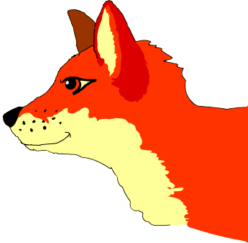

Using Role Plays

The role play can be built up through various stages and should be introduced when pupils are very familiar with the story.

Lesson 1:
Project story on to screen to aid understanding.
Read through the role play in groups and ask pupils to identify the key words in the text. Which words do we recognise? How do we remember them?

Lesson 2:
Read through the role play again, with the story displayed.
Give out the phrases of the role play and ask groups to sequence.
Pupils discuss in groups which order they think the text should go.
Allow groups to wander around and view other sequences.
Whole class feedback.

Lesson 3:
Read through the role play a third time.
Separate pupils into character groups (narrator, corbeau, renard).
Each character gathers with a group of pupils in the same role to practice the lines on the sentence cards and agree on the pronunciation, using their knowledge of phonics.
Discuss possible strategies to remember lines without the cards.

Lesson 4:
Read through the role play, encouraging characters to join in with the reading.
Spend half of the lesson time back in the groups from the last lesson, and then organise the final acting groups, with the correct role play characters.
Pupils practice and agree on possible props for next lesson.

Lesson 5:
Read through role play with whole class, with all pupils joining in for their parts.
Encourage pupils to only use the sentence cards as prompts if absolutely necessary.
Full rehearsal with props.
Finally, show the role plays, acted out to the class / school!
Role Play

Personnages: narrateur (N), corbeau (C), renard (R).

N : Il était une fois un grand corbeau noir et un petit renard malin. Les voici ! Ils habitent un joli bois près d’une petite rivière.

C : Bonjour ! Caw ! Caw !

R : Bonjour !

N : Le corbeau a faim.

C : Oui, j’ai faim. Voilà un bon morceau de fromage par terre !

N : Et il prend le fromage dans son bec noir.

C : Je suis très content !

N : Il retourne sur sa branche pour le manger.

N : Mais voici le renard. Le renard aussi a faim.

R : J’ai très faim. Quelle bonne odeur! C’est du fromage je crois. Que ça sent bon, très bon!

N : Il regarde le corbeau.

R : Bonjour Monsieur Corbeau. Vous êtes très joli! Vous êtes vraiment beau !
Je suis certain que vous avez aussi une très belle voix.
Si votre voix est aussi belle que votre plumage vous êtes vraiment le phénix de ce petit bois.

N : Le grand corbeau noir est très heureux et très fier. Alors il ouvre son bec noir et chante une jolie chanson pour le renard.

C : Ah zut! J’ai laissé tomber le fromage. Le voilà par terre !

N : Et le renard malin ? Il mange le fromage tout de suite bien sûr.

R : Merci beaucoup Monsieur Corbeau, vous êtes très gentil mais vous êtes aussi très bête, très idiot.
Soyez sage ! N’écoutez pas les flatteurs. Merci pour le fromage !

N : Le grand corbeau noir est triste, très triste. Il a envie de pleurer.

C : Zut ! Maintenant je n’ai pas de dîner et j’ai faim.
Le renard a mangé mon fromage. Je suis idiot.
Je ne vais jamais écouter les flatteurs, et surtout pas les petits renards malins.

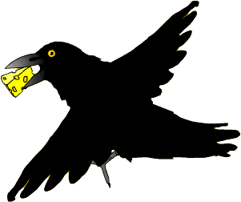
Le Corbeau et le Renard

Le corbeau noir
Le bois vert
À côté de la rivière
La rivière

Un bon morceau
De fromage par terre
À côté de la rivière
La rivière

Il est descendu ce grand corbeau
Et dans son bec ce bon morceau
Bon morceau

Le renard malin
Il avait faim
Il a vu le morceau dans le bec du corbeau
Le bec du corbeau

“Monsieur Corbeau” a dit le renard malin
“J’imagine que vous chantez très bien
Très bien!”

Le grand corbeau
Était vraiment fier
Et le bon morceau
Est tombé par terre
Tombé par terre

Le grand corbeau
Se sentait honteux
N’écoutez pas les flatteurs
Les flatteurs!

MFL KS2 Framework for year 3

 | Oracy |  | Literacy |  | Intercultural Understanding | Knowledge about Language | Language Learning Strategies
O3.1  3.4  O3.2  O3.3  O3.4 | To listen and respond to simple stories, finger rhymes and songs  - Identify rhyming words  - Perform finger rhymes and sing songs  - Listen to stories  - Join in with storytelling  To recognise and respond to sound patterns and words  - Listen with care  - Identify sounds which are the same as or different from English  - Speak clearly and confidently  To perform simple communicative tasks using single words, phrases and short sentences  - Remember, retain and recall vocabulary  - Ask and answer questions  To listen attentively and understand instructions, everyday classroom language and praise words  - Repeat words and phrases spoken by the teacher  - Develop speaking strategies such as mime and gesture to convey meaning.  - remember a sequence of spoken words  - Use physical response to show understanding | L3.1  L3.2  L3.3 | To recognise some familiar words in written form  - Understand words displayed in the classroom  - Identify and read short simple words when listening to familiar rhymes or stories or songs  - Read short messages  To make links between some sounds, rhymes and spellings and read aloud familiar words  - Identify characters and letter strings which are the same as or different to English  - Pronounce accurately the most commonly used characters and letter strings  - Read aloud a familiar sentence, rhyme or poem  To experiment with the writing of short words  - Copy simple, familiar words using a model  - Write some single words from memory | IU3.1  IC3.2  IU3.3  IU3.4 | To learn about the different languages spoken by children in the school  - Be aware of linguistic and cultural diversity  To locate country / countries where the language to be studied is spoken:  - Identify some of the countries where the language is spoken  - Know some facts about one country where the target language is spoken, e.g. climate, main towns, famous landmarks, produce  To identify social conventions at home and in other cultures  - Learn about polite forms of address  - Know how to greet native speakers  - Know some typical names  To make indirect or direct contact with country / countries of target language | Identify specific sounds, phonemes and words, linking sounds to meanings  Imitate pronunciation of sounds  Hear main word classes  Recognise questions and negatives  Recognise how sounds are represented in written form  Notice the spelling of familiar words  Recognise that languages describe familiar things differently  Recognise the centrality of language in communication  Recognise different language conventions to express politeness | Discuss language learning and reflect and share ideas and experiences  Use actions and rhymes to aid memorisation  Ask for repetition and clarification  Use context and previous knowledge to help understanding  Practise new language – speaking aloud or silently, speaking with a friend  Practise new language outside the classroom  Look at the face of the person speaking and listen attentively  Use gestures and mime to show understanding  Play games to help memorisation  Recognise words which the teacher mouths silently

MFL KS2 Framework for year 4

 | Oracy |  | Literacy |  | Intercultural Understanding | Knowledge about Language | Language Learning Strategies
O4.1  O4.2  O4.3  O4.4 | To memorise and recite a short text  - Learn finger rhymes, poems or short stories or a non-fiction text  To listen for specific words and phrases in a song, poem or story  - Listen with care  - Use physical response to show recognition and understanding of key words and phrases  - Look carefully at the person who is speaking  To listen for sounds, rhyme and rhythm  To ask and answer questions on several topics  - Ask how to say something in the target language  - Ask someone to clarify or repeat  - Speak clearly and confidently | L4.1  L4.2  L4.3  L4.4 | To read and understand a range of familiar written phrases  - Match phrases and short sentences to picture or topics  To follow a short familiar text, listening and reading at the same time and them read part of the text aloud  - Make links between the spoken and written words  - Identify common spelling patterns in letter strings  - Pronounce letter strings, words and phrases accurately with good accent  To read some familiar words and phrases aloud and pronounce them accurately  - Use words which they practice on a regular basis, e.g. numbers, days, weather  To write simple words and phrases using a model and some words from memory | IU4.1  IC4.2  IU4.3  IU4.4 | To learn about festivals and celebrations in different cultures  - Learn how children of different cultures celebrate special days  - Identify similarities and differences  - Learn simple phrases to celebrate festivals  To know about some aspects of everyday culture and compare them to their own:  - To learn and compare pastimes of children of different cultures  To compare traditional stories  - Compare characteristics of simple stories between cultures  - Learn about aspects of the writing system of a different language  To learn about ways of travelling to the target country / countries  - Revise location of country / countries where target language is spoken  - Identify route from own locality to specified destination | Reinforce and extend recognition of word classes and understand their function  Recognise and apply simple agreements, singular and plural  Apply question forms  Develop awareness of communication strategies  Recognise that texts in different languages will often have the same conventions of style and layout  Apply phonic knowledge of the foreign language to support reading and writing  Identify a different writing system | Discuss language learning and reflect and share ideas and experiences  Use actions and rhymes to aid memorisation  Ask for repetition and clarification  Use context and previous knowledge to help understanding  Practice new language – speaking aloud or silently, speaking with a friend  Practice new language outside the classroom  Plan and prepare for a language activity  Read and memorise words  Use a mental association to help remember words  Sort words into categories  Apply knowledge about letters and simple grammatical knowledge to experiment  Use context and previous knowledge to determine meaning and pronunciation

